Enter the Gungeon: How To Make A Hard Game Fun

By Kevin Dinh

There used to be a generalization regarding gaming. It was said it served as a form of escapism from the stresses of life, something to which to devote several hours in after a hard day of work. It was also thought it would lead to the misconception that games must be easy.

Now, for the gamers who want to pursue a much more grueling gaming experience, plenty of titles exist to cater to those needs. Touhou, Geometry Dash and Cuphead are examples. Enter the Gungeon, unlike any other games in this category, offers very high replayability, despite its desk-smashing difficulty that can drive even the most hardened gamer to a corner.

Enter the Gungeon, developed by Dodge Roll and published by Devolver Digital, is categorized as a bullet-hell roguelike game. Bullet-hell is a genre where the character dodges a blinding amount of bullets on the screen, and roguelike is a sub-genre of dungeon crawler games where the character traverses through procedurally generated levels.

The general premise of Enter the Gungeon is that the characters you play have done something regrettable in the past and they seek to “kill their pasts” by finding parts of a gigantic silver bullet which allows them to travel into the past and alter it as they please. The game starts out quite uniquely, with the player choosing to be one of the original four characters, each having with their own storyline, in a starting room that slowly expands itself the more the player plays the game.

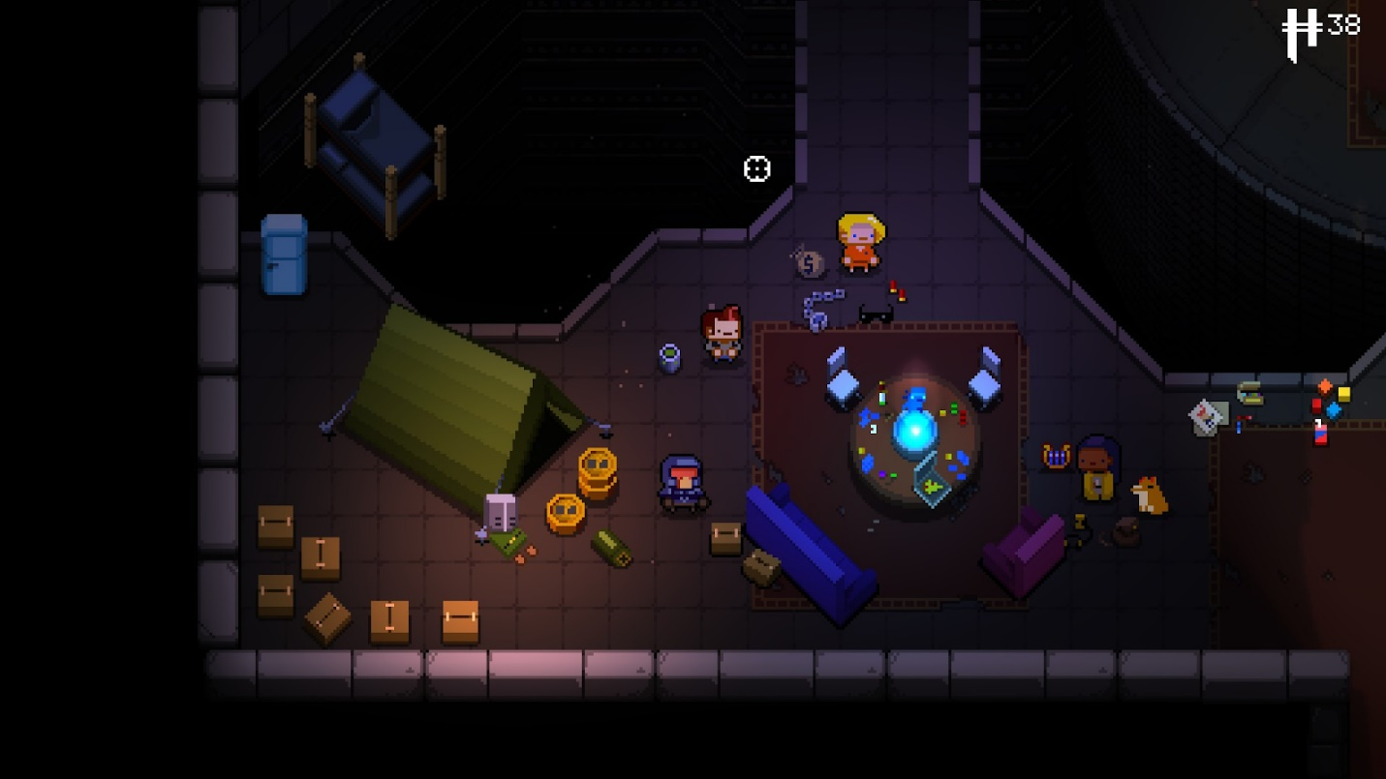
The starting room of the game, which is also called The Breach, where you choose one of the five characters: The Marine, The Pilot, The Convict, The Hunter. The room will have more elements the more you play the game.

The game is divided into five main areas, each having its own secret level which adds more content to the game. The five main areas are called: Keep of the Lead Lord, Gungeon Proper, Black Powder Mine, Hollow and The Forge. Each area is randomly generated, with a few affixed features that invite exploration. Each area has its own boss room, marked with a unique symbol on the map, that the player must defeat before progressing to the next area. The bosses are also randomly chosen: one of three per area. Each area contains two chest rooms of varying ranks of items that players must open with keys, with one chest guaranteeing a new weapon and the other one guaranteeing a passive item. The player starts out with three hearts. They lose half a heart upon taking damage. Blanks are used to clear out the room if the amount of bullets gets too hectic. Keys not only unlock chests, but unlock various other features within the game. Shells are used to buy items within a shop in each area. Players have a weapon slot, which can hold an unlimited amount of weapons and only one passive item slot.
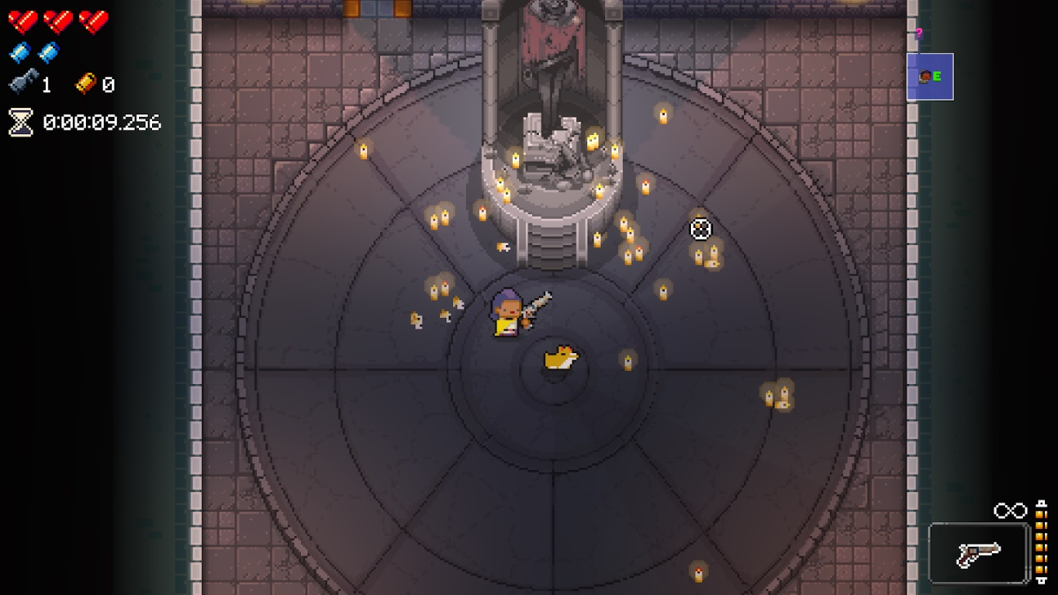
Keep of the Lead Lord

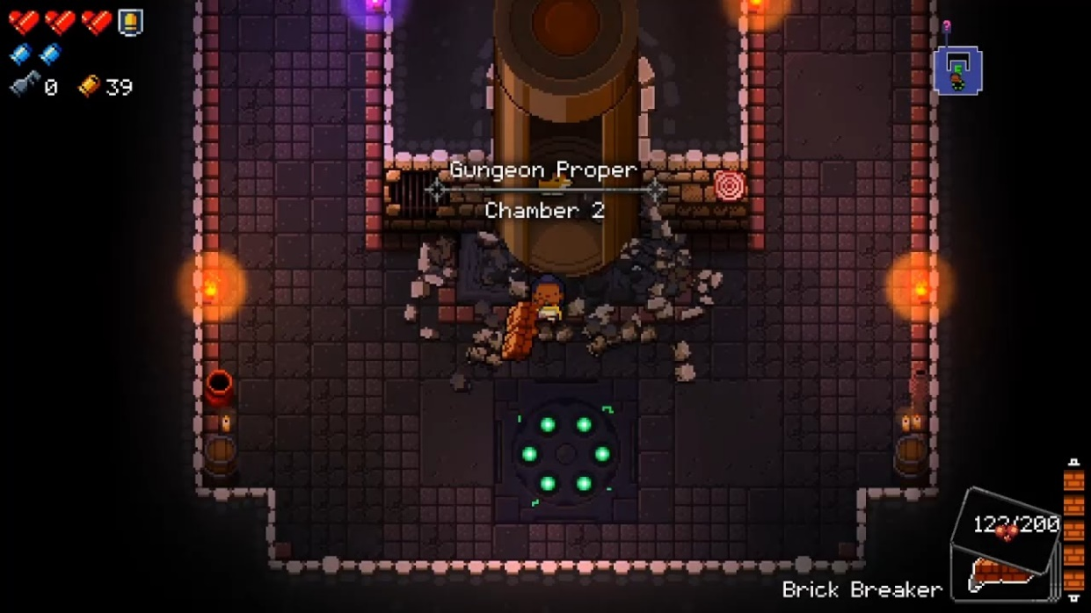
Gungeon Proper
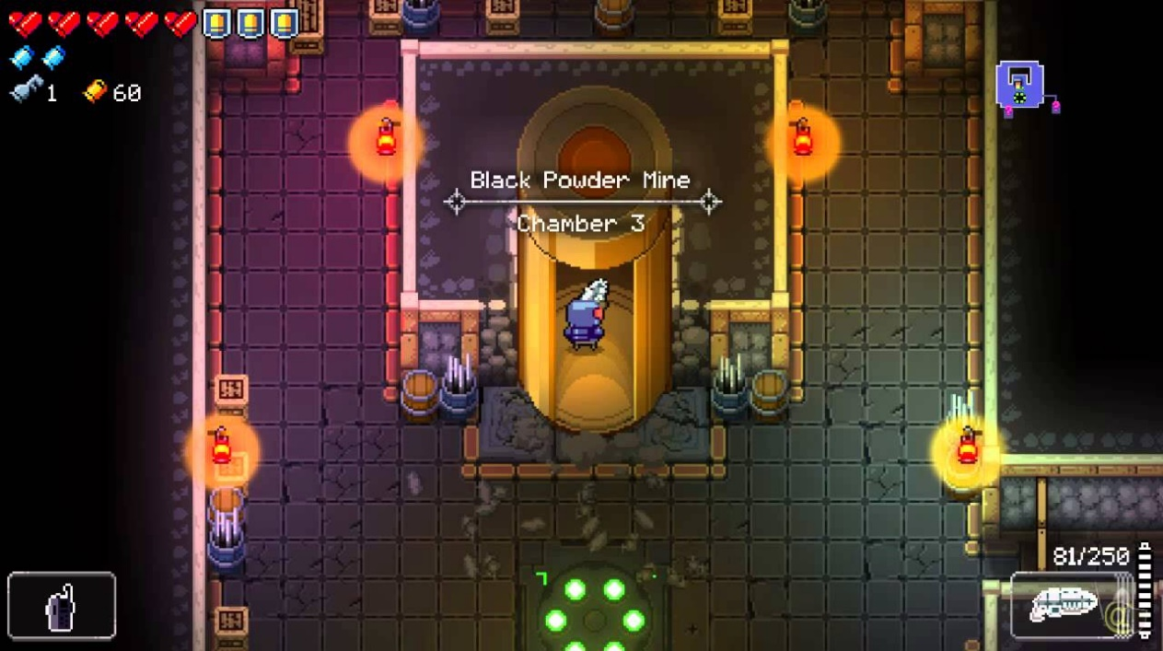
Black Powder Mine
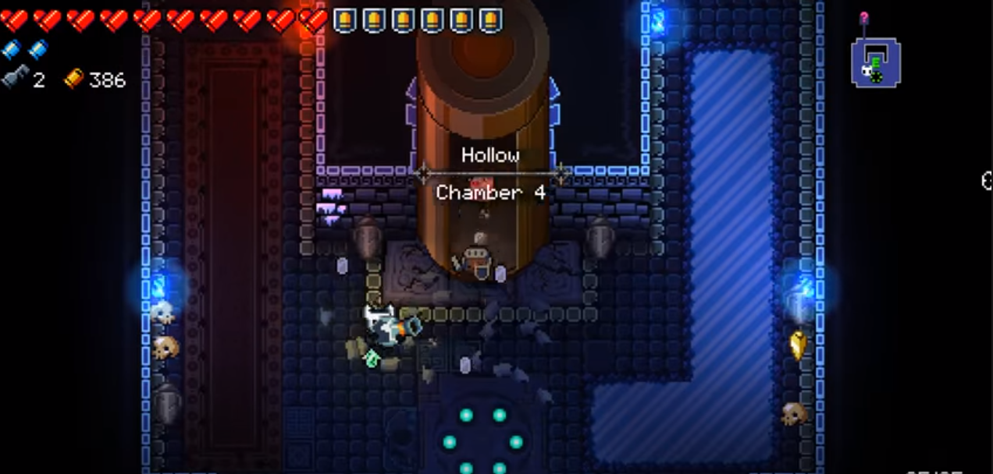
Hollow
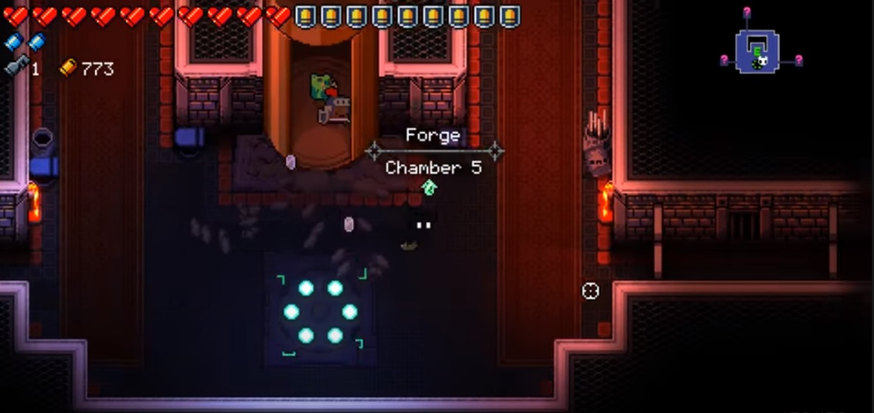
Forge

The mind-boggling amount of sub-content and secrets hidden behind the original exteriors of the Enter the Gungeon offers a near limitless amount of replayability. To “kill the past” or to not “kill the past”, players can choose whether or not to collect the pieces of the bullet that can kill the past in each area. Within the main areas contain other hidden rooms. There are “non-player characters” within the game that the player can unlock via a Cell Key. They will reappear in The Breach and offer you many other unlockables, including weapons which can be unlocked through either purchases or challenges. Game modes can completely change how the game is played, and an elevator system allows the player to travel to later levels quickly.
The weapons themselves are incredibly expansive, with specific combinations yielding what is called a synergy that allows the combination to get stronger than its base form. Players can also unlock new characters by progressing through the game and doing certain things within the areas of the games.
Listing every single feature of the game is close to impossible. The game pushes player to explore all of those features, resulting in endless possibilities. When the player dies, it is not the end of the game, as each death allows the player to learn more hidden features. The areas within the game incentivize the player to explore every feature, and to unlock more and more, resulting in nearly endless replayability.
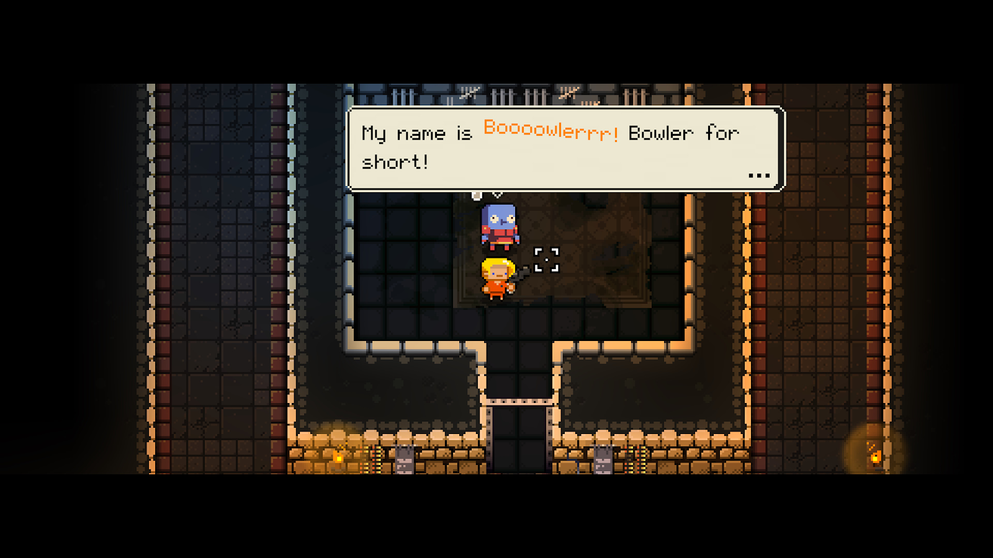
Cells containing a variety of NPCs which can be opened via a Cell Key
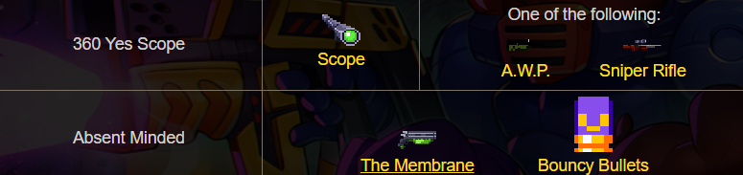
Examples of synergies within the weapons and passive items

Enter the Gungeon has achieved a rare state of neverending replayability with its incredible expansive amount of content in the base content. The explorable hidden content within the game not only contributes to gameplay, but to the lore of the world that the game sets in place, making for hilarious and intriguing experiences.
There is no way to go deeper within the initial layer of the game without spoiling the rest. It would be best for new players to play the game and experience this indie masterpiece to truly get the scope of the expansiveness of this title.

